Python / Selenium Study Questions

1. Explain some differences between using Firefox vs Chrome for inspecting elements.
   1. Firefox and Chrome both have developer tools but Firefox had some Add-ons which made searching for an element by Xpath a bit easier – and those add-ons grow out of compatibility with newer versions of Firefox.
   2. Chrome’s developer tools have an Element pane (like Firefox’s “Inspector” pane) but you can search by string, selector, or xpath. This Element pane will also return the number of nodes for that element.
2. How do you see if an element has multiple nodes?
   1. In Firefox, you would need to run an xpath query in the console and see if it returns 0 or an array of elements. Alternatively, you can use Firefox add-ons by using a shorter xpath query.
   2. In Chrome you can easily see the number of nodes in the Element tab when you search for the element and it will tell you in the search bar.
3. Explain a few ways you can search for an element
   1. You can right click on an element and click “inspect element” (Firefox) or “inspect” (Chrome)
   2. You can open the Developer Tools on the browser and hover over the element (Firefox). Firefox also has an inspector button when enabled, if you click on an element it will highlight the element in the DOM.
   3. You click on the “inspector” button in the Developer Tools and then click on the element to highlight the element in the DOM (Chrome)
4. How can you tell if an element is embedded within an iframe? What is the problem with iframe elements?
   1. You can search for an element normally, then look through the hierarchy and you can see the markdown for iframe.
   2. Selenium cannot find elements within iframe.
5. What are the different locators to find elements on a web page?
   1. ID
   2. Name
   3. XPath
   4. CSS Selector
   5. Link Text
   6. Partial Link Text
   7. Class Name
   8. Tag Name
6. How do you find an element on a web page using selenium webdriver with python?

driver.find_element_by_id(“id”)

driver.find_element(By.XPATH, “xpath”)

1. How do you find an element list on a webpage using selenium webdriver with python?

driver.find_elements_by_id(“id”)

driver.find_elements(By.XPATH, “xpath”)

1. Which locator has the best performance when working with selenium webdriver?
   1. Best option is finding by ID if it is unique and static
   2. If it is not static and changes w/ page load (dynamic), we should use CSS
   3. If CSS is hairy, then use XPath
   4. We can also use Link Text and class name If they give us unique results
2. Why should we not depend on class name, tag name, link text often?
   1. Because multiple elements on a web page can share the same class name and tag name.
   2. Text could also be the same on multiple links
3. What are the different ways to build an xpath?
   1. Absolute vs relative
   2. Contains / starts-with keywords
   3. Siblings / Parent relationships
   4. Attributes
   5. Text properties (search by text)
4. Difference between relative and absolute xpath
   1. Absolute = starts at the root (html).
   2. Relative = finds an element that returns one node, and then builds an xpath for the desired node off of that.
5. Difference between single slash / and double slash //
   1. Single slash = immediate child
   2. Double slash = Finds the tag all throughout the DOM, not just immediate child
6. Xpath or CSS? Performance?
   1. IDs are for best performance, so if there is an ID start with that if the ID is unique and non-dynamic.
   2. Unique names = same thing.
   3. CSS
   4. Xpath at a last resort if there are no unique ID’s, names, etc. Slower in terms of performance but reliable.
7. What are the three ways to select dropdown option elements?
   1. Value: select_by_value()
   2. Visible Text: select_by_visible_text()
   3. Index: select_by_index()
      1. Two ways: Can take a string or int as an argument
8. Provide the methods for the following desired actions:
   1. Maximizing the window: driver.maximize_window()
   2. Get the title of a page: driver.title and assign the property to a variable
   3. How do you refresh the window? driver.refresh()
   4. How do you go back and forward in history? driver.back() and driver.forward()
   5. Get the current url: driver.current_url and assign the property to a variable
9. What is the difference between driver.close() and driver.quit() ?
   1. driver.close() -> closes the current window
   2. driver.quit() -> quits the driver and closes every associated window
10. How to click an element and how to type on a text box?

driver.click()

driver.send_keys(“Text to type”)

1. Which method can be used to find if the element is enabled or disabled?

First, find the element using: element = driver.find_element() query

element.is_enabled()

1. Which method can be used to find if a radio button or checkbox is selected?

element = driver.find_element() query

element.is_selected()

1. Which method can be used to find if the element is displayed or hidden?

element = driver.find_element() query

element.is_displayed()

1. Which class from selenium webdriver can be used to work with dropdown elements?
   1. Select Class
2. How do you find the text on an element?
   1. Make a new variable, find the element, then make a 2nd variable to capture the text

element = driver.find_element() --- query

output = element.text

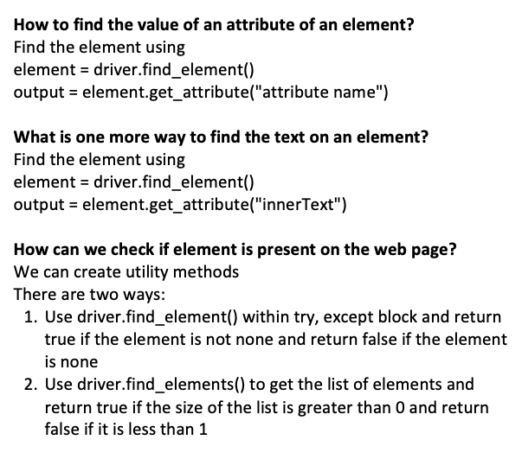

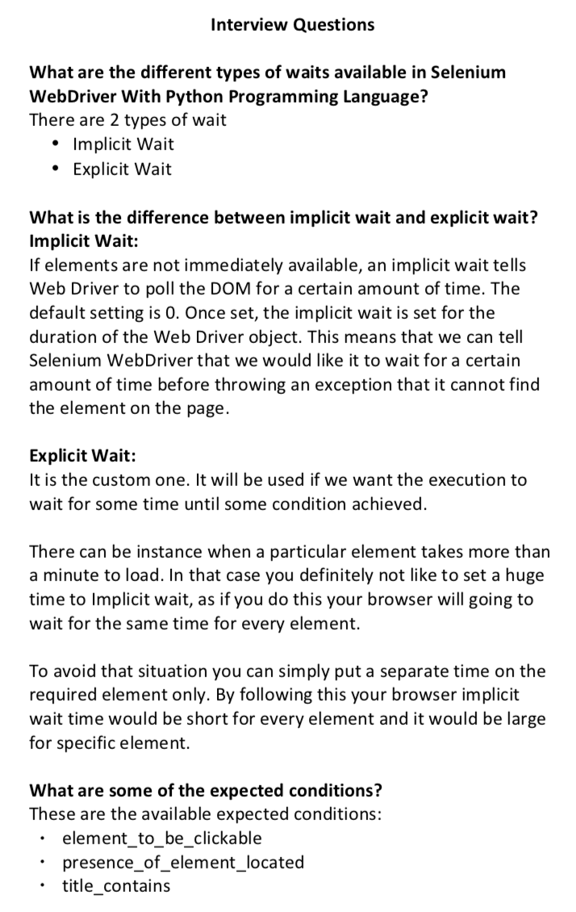

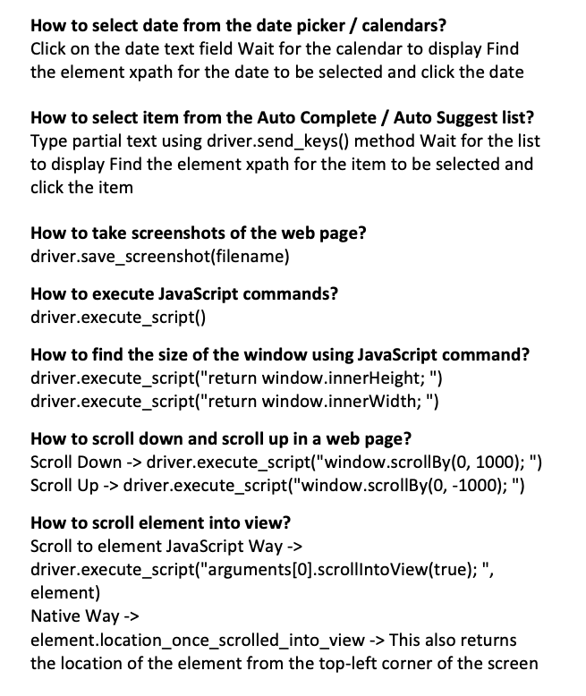

What are the two ways to find a date in a calendar?

1. find the date element

2. find all the date elements that are not disabled, put it into a list, and iterate over that list